- F(x) = 4x^3 + x^4
- X-axis interception points
Y = 4x^3 + x^4
0 = 4x^3 + x^4
4x^3 + x^4 = 0
X^3(x+4) = 0
X^3 = 0 and (x+4) = 0
Therefore, x = 0 and -4
The x-interceptions points are:
= (0, 0) and (-4, 0)
- If f’(x) > 0 then f(x) is increasing.
If f’(x) < 0 then f(x) is decreasing
f’(x) = 12x^2 + 4x^3
f’(x) > 0: -3 < x < 0 or x > 0
f’(x) <0: x < -3
Therefore, increasing on: (-3, 0), (0, ∞)
Decreasing on: (-∞, -3)

Where first derivative equals zero, local maxima and minima are obtained.
i.e. x = -3 local minimum
(x, f(x)) = (−3, −27)
No Maxima
- Inflection points – points on the graph at which the second derivative is equal to zero, undefined and changes sign.
When f’(x) > 0 then f(x) concave upwards.
When f’(x) < 0 then f(x) Concave downwards.
f’’(x) = is equal to zero or undefined: x = -2, x = 0
f’’(x) > 0: x < -2 or x > 0
f’’(x) < 0: -2 < x < 0
Inflection points: (-2, -16), (0, 0)

Concave upward on: (−∞, −2) and (0, ∞)
Concave downward on (-2, 0)
- Graph
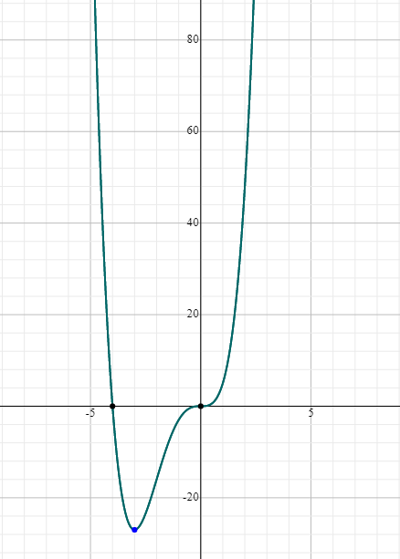
- F(x) = x^2 – x – 2 / x + 2
f’(x) = (x^2 – x – 2) / (x + 2)^2
f’(x) > 0: x < -4 or x > 0
f’(x) < 0: -4 < x < -2 or -2 < x < 0
Increasing on: (−∞, 4), (0, ∞)
Decreasing on: (-4, -2), (-2, 0)
Where first derivative = 0
Rel. max. at x = (-4, -9)
Rel. min. at x = (0, -1)
- F(x) = 10+12x^2+x^3-1/4(x^4)
When f’(x) > 0 then f(x) concave upwards.
When f’(x) < 0 then f(x) Concave downwards.
f’’ = -3x^2 + 6x + 24
Where f”= 0 or undefined x = -2, x = 4
f’’(x) > 0: -2 < x < 4
f’’(x) < 0: x < -2 or x > 4
Conc. Up on = -2 < x < 4
Conc. Down on = −∞ < x < -2 and 4 < x < ∞
Points of inflection: x = -2, x = 4
- (4x^2 + 12 x)/(x^2+x-6)
y = (4x^2 + 12 x)/(x^2+x-6)
Vertical asymptote of this f is the x=m where limit of the function is infinite
So where the denominator = 0
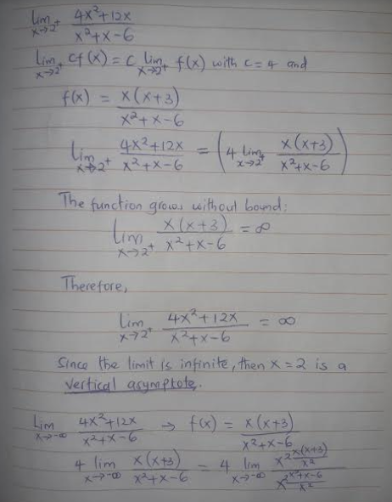
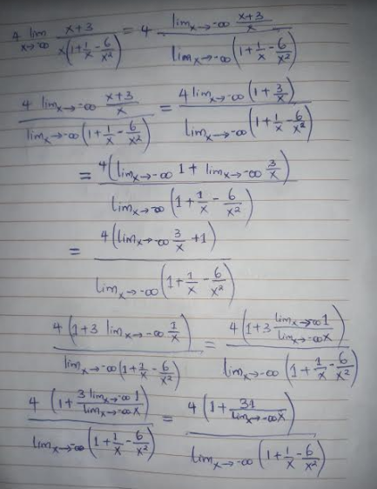
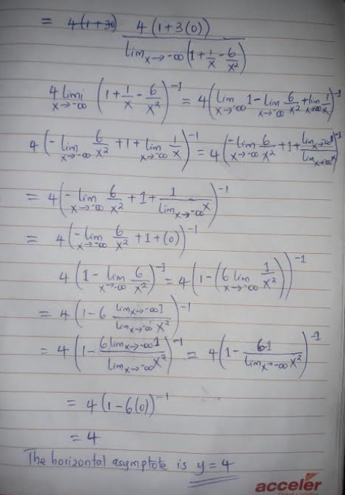
(4x^2 + 12 x)/(x^2+x-6) 4 as x +- ∞
(4x^2 + 12 x)/(x^2+x-6) +- ∞ as x 2
Vertical: x = 2
Horizontal: y = 4
- F(x) = x^3-6x^2-15x+100
F(x) has an absolute maximum at x₀ on the interval (x, y) if f(x₀) >= f(x) for all x in (x, y).
F(x) has an absolute maximum at x₀ on the interval (x, y) if f(x₀) <= f(x) for all x in (x, y).
Find the critical points of f(x):
Compute the critical points of x^3 - 6 x^2 - 15 x + 100
The domain of f(x) = x^3 - 6 x^2 - 15 x + 100 on -3<=x<=4 is {x element R : -3<=x<=4}
The interior of the domain is {x element R : -3<x<4}:
f(x) = x^3 - 6 x^2 - 15 x + 100 when -3<x<4
Finding the derivative of x^3 - 6 x^2 - 15 x + 100.
To start, compute f'(x):
d/( dx)(x^3 - 6 x^2 - 15 x + 100) = 3 x^2 - 12 x - 15
= 3 (x - 5) (x + 1):
f'(x) = 3 (x - 5) (x + 1)
Find where f'(x) is zero by solving 3 (x - 5) (x + 1) = 0 when -3<x<4.
Solving 3 (x - 5) (x + 1) = 0 yields x = -1:
x = -1
Find where f'(x) = 3 (x - 5) (x + 1) does not exist when -3<x<4.
f'(x) exists for all x such that -3<x<4:
3 (x - 5) (x + 1) exists for all x such that -3<x<4
The only critical point of x^3 - 6 x^2 - 15 x + 100 is at x = -1:
x = -1
Determine the endpoints of the domain of f(x).
The domain of x^3 - 6 x^2 - 15 x + 100 on -3<=x<=4 is {x element R : -3<=x<=4}:
The endpoints of {x element R : -3<=x<=4} are x = -3 and 4
Evaluate x^3 - 6 x^2 - 15 x + 100 at x = -3, -1 and 4:
x | f(x)
-3 | 64
-1 | 108
4 | 8
Establish the largest and smallest values that f achieves at these points.
The largest value corresponds to a global maximum, and the smallest value corresponds to a global minimum:
x | f(x) | extrema type
-3 | 64 | neither
-1 | 108 | global max
4 | 8 | global min

f(x) = x^3 - 6 x^2 - 15 x + 100 has one global minimum and one global maximum, for -3<=x<=4:
Answer: |
| f(x) has a global maximum at x = -1
f(x) has a global minimum at x = 4
Absolute Maximum = (-1, 108)
Absolute Minimum = (4, 8)
- Increasing and decreasing
f(x)>0 on (-3,-1)U(-1,1)
=> f(x) is increasing on (-3,-1)U(-1,1)
f(x)<0 on (-∞, -3)U(1,3)U(3, ∞)
=> f(x) is decreasing on (-∞, -3)U(1,3)U(3, ∞)
Concavity
f’’(x)>0 => an extreme value
f’’(x)>0 => on (-4,1) U(3,∞)
Concave up at (-4,1)
f’’(x)<0 => an inflection value
f’’(x)>0 => on(- ∞,4)U(-4,1) U(1,3)
Concave down (1,3)
Graph
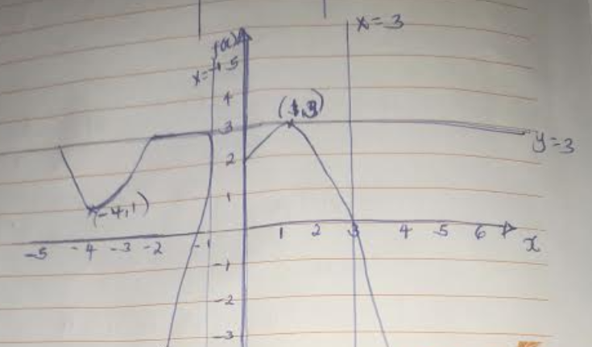
- f(x) = 6x²-x³+10
Now, f’(x)= -3x²+12x
To find critical points, f’(x)=0
-3x²+12x=0
Solving for x,
-3x(x-4)=0
-3x=0 (x-4)=0 gives x=0, x=4
Finding the second derivative f’’(x)= -6x+12
Finding, f’’(0)= -6(0)+12
f’’(0)= 12>0 relative minimum at (0, f(0))= (0,10)
f’’(4)= -6(4)+12
f’’(4)= -12< 0 relative maximum at (4, f(4))= (4,42)

- Let the horizontal side =x
Let the vertical sides=y
Area = 135,000sqft
Cost=3(2x) + 2(2y)
Cost C(x)= 6x+ 4(135000/x)
C(x)= 6x+ 4(135000/x)
C(x)= 6x+ 540000/x
C’(x) = 6 -540000/x²
At minimum C’(x)=0
6 -540000/x²=0
6x^2=540000
- X=300
Minimum cost C(300) = 6(300) -540000/(300^2) = 1800-6 = 1794
Minimum cost =$1794

